Website comments:

Page - 1 Home

On the top –

Replace with: Servicing Condos & Co-ops Across NYC



Please capitalize the first letters: Condo and Co-op.
Take out the word: “boards” and replace it with: buildings

Replace phone number 3 times on the first page. 718 536 1200

What we do section –

Please take out : build for boards.

What we do section –
We track NYC’s ever-changing compliance calendar so your board never misses a filing or inspection deadline.
Please take out the word: your board and replace with: you.

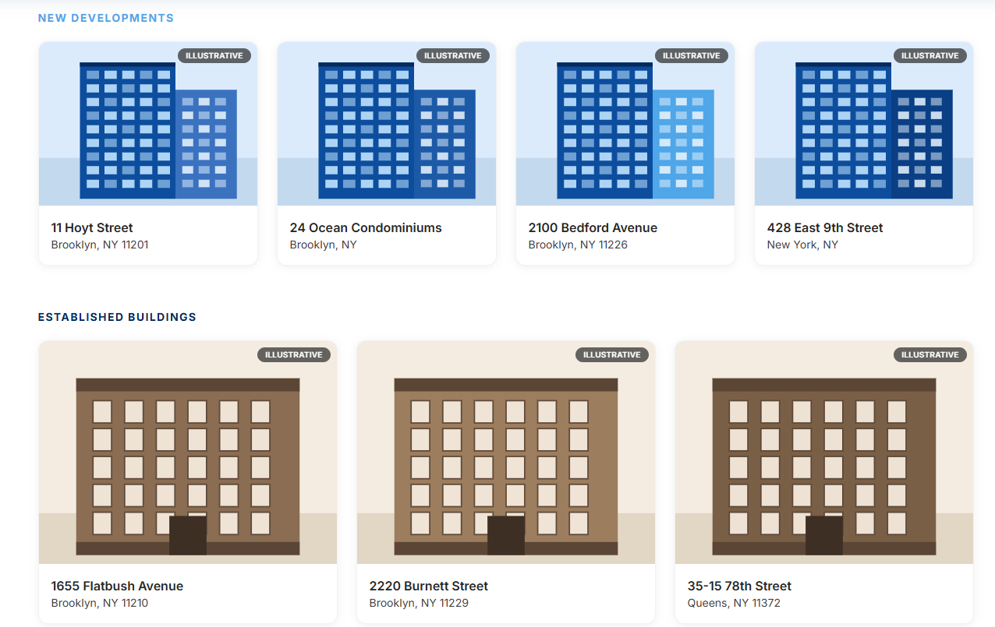

Please update this section. We don’t manage any of these buildings listed. I just wanted SAMPLE photos of old buildings and new buildings showing prospective that we handle old & new buildings. Please see attachments on this email of sample photos. If the photos are not clear enough and/or you want to add your own that’s ok as well. The main goal is to show old & new NYC condo & co op samples, so they know what we do.

Client testimonials
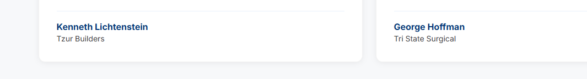

Add CEO to them. They are both CEO’s of the company. I’ll leave the ball in your court.

Page 2 – about section

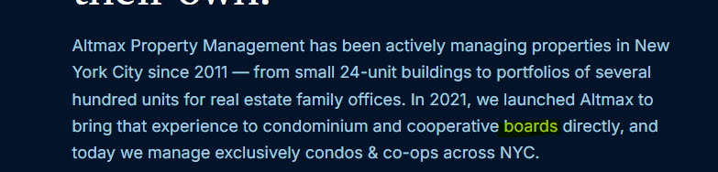
Replace “boards” with: buildings

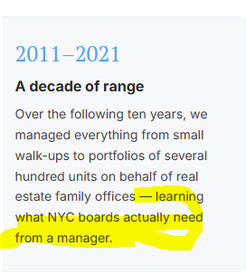
Please delete highlighted.

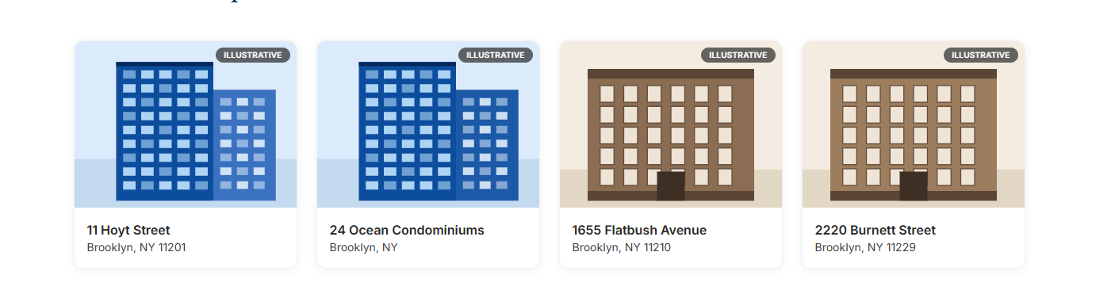

Please replace with SAMPLE photos of new and old condo & co op buildings. Attached in the email.

Page 3 – Services


Please replace “board” with: building.

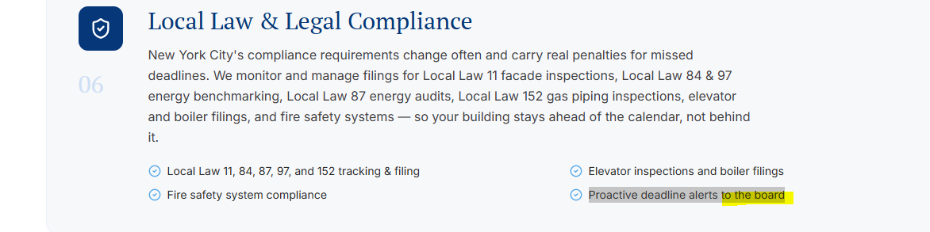

Delete highlighted “to the boards”

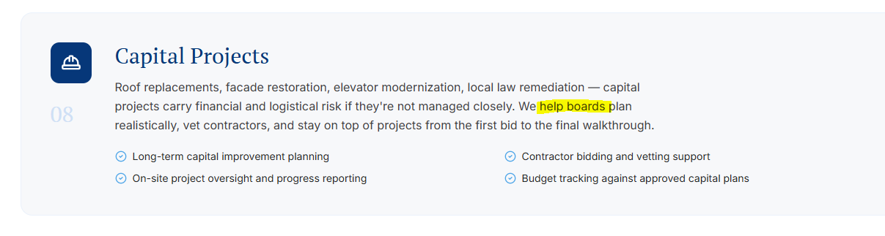
Remove “help boards”

Page 4 –
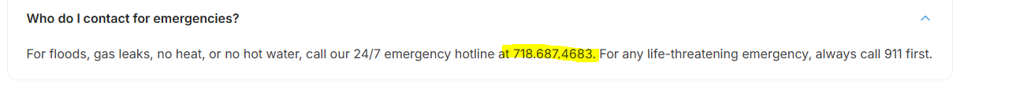
Change phone number to: 718 536 1200

Replace: Yes. We prepare annual budgets based on ….

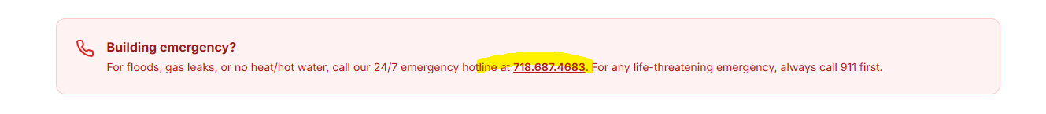
Replace phone number 718 536 1200

Page 5 –
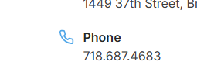
New Phone Number: 718 536 1200



Change phone number in the bottom section as well. 718 536 1200

